GAS LEAKAGE MONITORING AND ALERTING SYSTEM FOR INDUSTRIES CIRCUIT DIAGRAM AND SCHEMATIC VIEW

**TEAM ID : PNT2022TMID02412**

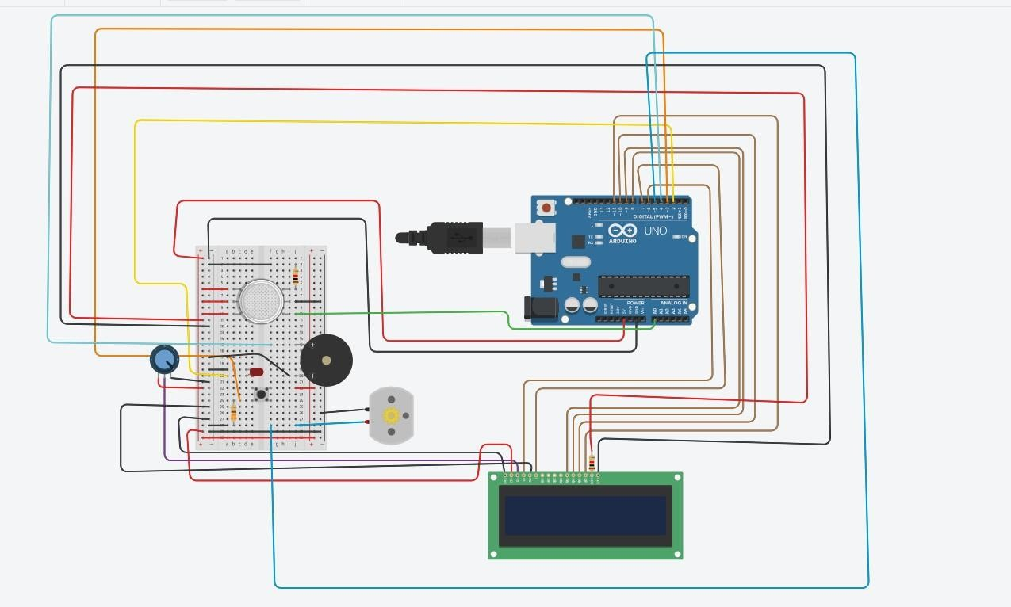CIRCUIT DIAGRAM: